УДК XXX.XXX

**CONTRIBUTION TITLE**

**First Author 1** (post-graduate student), **Second Author 1** (student)

**Scientific supervisor – PhD, Professor Name Surname1**

**1**ITMO University

xxx@yandex.ru

The work was completed within the research topic No. XXX “Topic name”.

**Abstract**

The abstract should briefly summarize the content of the article, in 150-250 words.

**Keywords**

First keyword, second keyword, third keyword (no more than seven keywords).

**НАЗВАНИЕ СТАТЬИ**

**Иванов И.И.1** (магистрант), **Петров П.П.1** (магистрант)

**Научный руководитель – доктор технических наук, профессор Сидоров С.С.1**

**1**Университет ИТМО

xxx@yandex.ru

Работа выполнена в рамках темы НИР №XXX «Название темы».

**Аннотация**

Аннотация должна кратко излагать содержание статьи, в объеме 150–250 слов.

**Ключевые слова**

Первое ключевое слово, второе ключевое слово, третье ключевое слово (не более семи ключевых слов).

The first paragraph should present a substantive statement of the issue under consideration, a brief analysis of known solutions, criticism of their shortcomings, the advantages and features of the proposed approach.

The main text should present the statement of the problem being solved, state and explain, if necessary prove the obtained statements and conclusions, provide the results of experimental studies or modeling illustrating the statements made.

The last paragraph should briefly formulate the main results, comment on them and indicate the directions for further development of the problem.

At the end of the article, a list of references is provided (no more than 5 items). All sources listed in the list should be referenced in the text of the article. When placing a reference to a source used at the end of a sentence, a period is placed after the brackets (incorrect [3.], correct [3].).

The article should be fully typeset in any of the Microsoft Word text editors with the following parameters:

* Times New Roman font – 12 pt;
* alignment – ​​by width;
* line spacing 1;
* margins – top and left – 25 mm; bottom – 20 mm; right – 20 mm.
* paragraph indent – ​​10 mm.

The accepted notations are deciphered directly in the text. Abbreviations should not be used, except for the generally accepted ones (i.e., etc., etc.). Case endings are used only for ordinal numerals. Formulas are typed in the Microsoft Equation 3.0 editor or (better) MathType. Individual variables in the text may be typed in text mode. It is not allowed to insert formulas from the MatCad and MathLab packages. When inserting formulas into the text, it is not allowed to convert the formula to a figure format. The location of formulas in the text, punctuation marks after formulas and the scheme for decoding notations are shown below:

${A(R)}_{верх.гр.}= R_{ср}+ ∂,$ (1)

${A(R)}_{ниж.гр.}= R_{ср}- ∂,$ (2)

where *A*(*R*)верх.гр. is the upper set limit of the range of values ​​of the system risk level; A(R)ниж.гр. is the lower set limit of the range of values ​​of the system risk level; *R*ср. is the average value of the system risk level; ∂ is the standard deviation from the value of *R*ср.

Pictures and graphs are placed in the center of the page. When inserting pictures, use the “text wrap” option. The title of the picture (Times New Roman 11, straight) should not be included in the picture format.

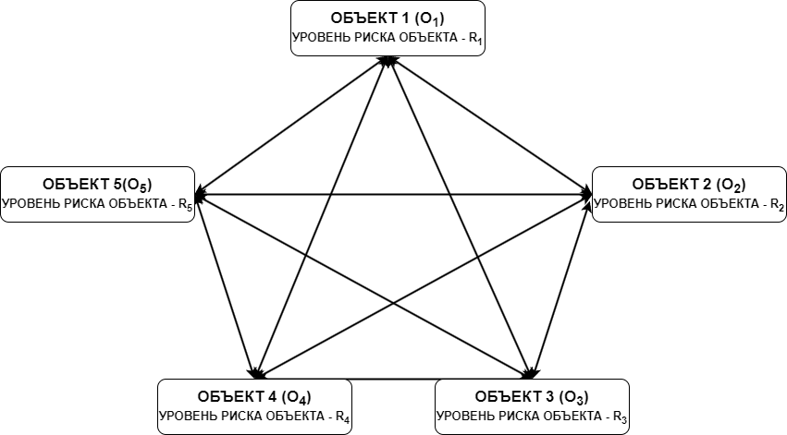

Рис. 1. Название рисунка

The only figure is signed with the word "figure", and when referring to it, the word "figure" must be written without abbreviation. If there are several figures, then the figures are numbered, and a reference to them in the text of the article is required: "... in Fig. X ...". If there are inscriptions in the figure field, their size must correspond to the font size of the main text (font size not less than 12 pt). According to this requirement, the size of the figure must be scaled, but with a limitation: the image size must not exceed 0.5 of the page vertically.

Tables are placed after the first mention of them in the text.

The table title begins with the word "Table" and its serial number, which is located above the table on the right without an indent (Times New Roman 11, regular font). The table title is written below it (Times New Roman 11, bold font, centered). The data in the table body are either centered or left-aligned (Times New Roman 11, regular font).

The only table begins with the word "Table" without a number, and when referring to it in the text, the word "table" must be written without an abbreviation. If there are several tables, they are numbered. All tables must be referenced in the text of the article: "... in Table X ...".

Table

**Brief description of variables**

|  |  |  |  |  |  |
| --- | --- | --- | --- | --- | --- |
| Item No. | Probability of threat realization, *P*угрозы | Probability of behavioral anomaly, *P*повед. аном | Probability of risk anomaly,  *P*аном. риска | Threat level, *L* | |
| 1 | $P_{угрозы}$ = =[0…1] | $P_{повед. аном.}$ = =[0…1] | $P_{аном. риска}$ = =[0…1] | [0…0,2) | Minimum threat level |
| 2 | [0,2…0,4) | Low threat level |
| 3 | [0,4…0,6) | Medium threat level |
| 4 | [0,6…0,8) | Significant threat level |
| 5 | [0,8…1) | Critical threat level |

The list of references is titled "References" and is given at the end of the article. The list is compiled in the order of their mention in the text, which are placed in square brackets, for example: [1]. The list font is Times New Roman 12 pt, normal. The list numbering is automatic, without a paragraph.

The list is given in accordance with the requirements of GOST 7.1 "Bibliographic record. Bibliographic description. General requirements and rules for compilation." A sample of the list format is given below.

**Literature**

1. EdgeЦентр спрогнозировал рост кибератак на бизнес в 2024 году [Электронный ресурс]. Режим доступа: https://www. gazeta.ru/tech/ news/2023/12 /23/21989557.shtml (Дата обращения 10.03.2024).
2. Авсентьев А.О. Проблема построения многоагентных систем защиты информации на объектах информатизации от утечки по техническим каналам // Вестник Воронежского института МВД России. 2022. №. 3. С. 68–77.
3. Курилов Ф.М. Моделирование систем защиты информации. Приложение теории графов // Технические науки: теория и практика: материалы III Междунар. науч. конф. (г. Чита, апрель 2016 г.). – Чита: Издательство Молодой ученый, 2016. С. 6–9.
4. Семыкина Н.А., Шаповалова И.А. Математические модели в информационной безопасности: учебно-метод. пособие. – Тверь: Тверской государственный университет. 2020. 126 с.
5. Карганов В.В., Липатников В.А., Дементьев В.Е. Вероятностно-временная модель нарушителя при обеспечении информационной безопасности информационно-вычислительной сети // Вопросы оборонной техники. Серия 16: Технические средства противодействия терроризму. 2017. №. 9–10. С. 3–7.
6. Дилигенская А.Н., Золотарев В.В., Карпова Н.Е., Селигеев С.В. Децентрализованное управление информационной безопасностью на основе эмерджентного интеллекта в информационных системах // Прикаспийский журнал: управление и высокие технологии. 2023. № 2 (62). С. 42–50.